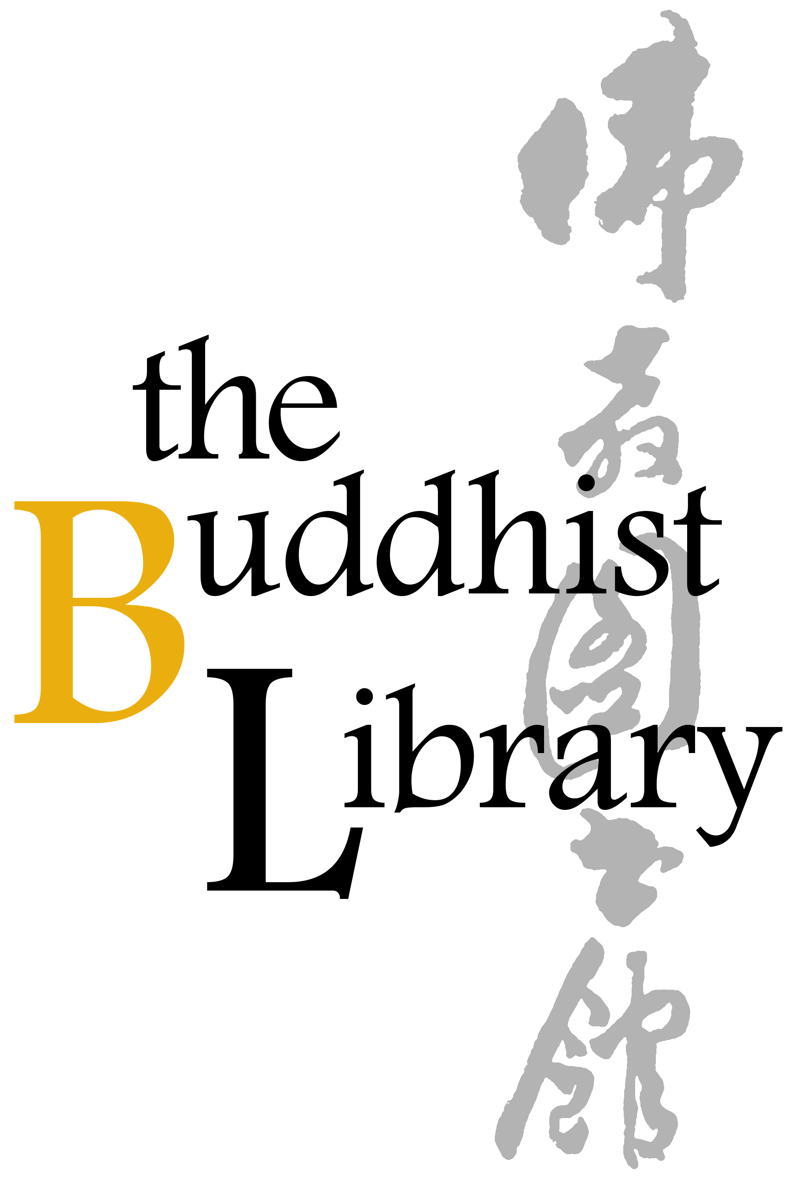
Singing Bowl Soundbath 2026

Date | 14 June 2026
Time | Session 1 : 4.30pm - 5.30pm | Session 2 : 6.15pm – 7.15pm
Venue | Buddhist Library Auditorium
Fee | $60.00/session
Notes | All proceeds collected will go towards the Library’s working funds.

Please (1) fill up this reply slip (2) make payment (Paynow /Bank Transfer) (3) email reply slip to info@buddhlib.org.sg (4) Please paste screenshot of PayNow or bank transfer in your email. (5) Kindly note that if you are new to the Library, we will add you to our Mailing List; we currently send out an e-newsletter once every 1-2 months to update visitors on our Library programmes.

Payment advice:
PayNow/PayLah to UEN S81SS0026HBRS (Buddhist Research Society Working Fund)

or scan QR code：
Internet transfer to DBS 0010193783 (Buddhist Research Society).
Cash and NETS are accepted at the Library.
*The Buddhist Library reserve the rights to change any part of the programme due to unforeseen circumstances.

Full Name
Email Address
Mobile Number
Session 1 or Session 2
Number of pax
(Optional) Any donations are welcome. Your donations help keep the Library running.
Total amount paid [ $60 x Number of pax + Donations (if any) ]

