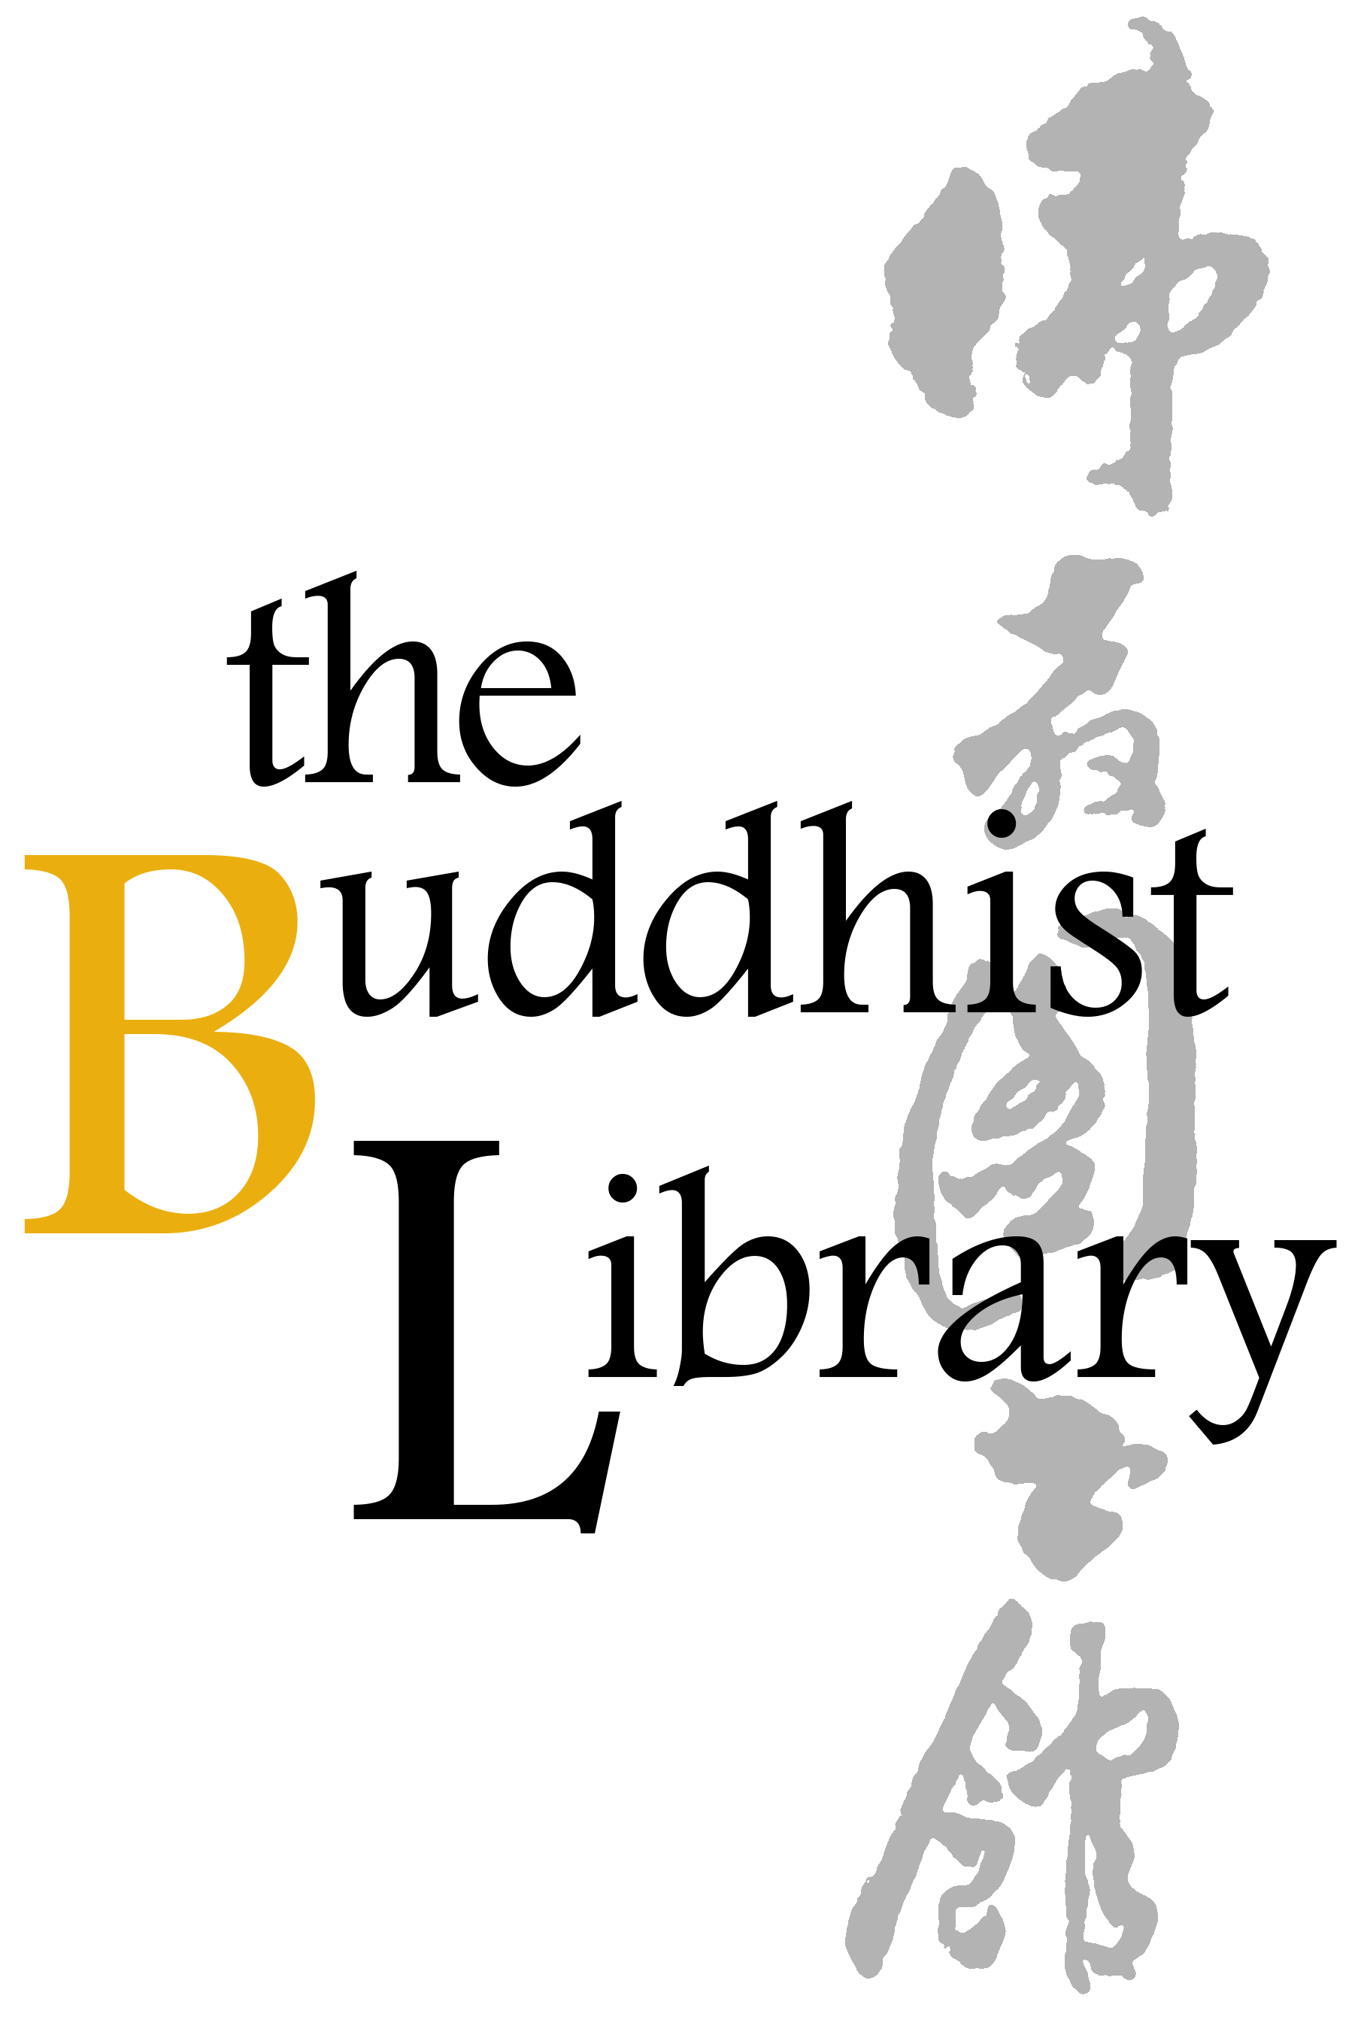
Weekly Candle Offerings Registration Form
每周供灯登记表格
Offering Days 供灯日 | Every Tuesday to Sunday每周二至周日
Cost 供灯费用 | $10.00 per candle offering每盏灯$10.00
Schedule | If no date is specified, your candle will be offered the next working day after payment and registration are confirmed.
请注意 | 若您未注明特定日期，我们将在确认您的登记与付款后，于下一个工作日为您供灯。
Please (1) fill up this reply slip (2) make payment (Paynow /Bank Transfer) (3) email reply slip to info@buddhlib.org.sg (4) Please paste screenshot of PayNow or bank transfer in your email. (5) Kindly note that if you are new to the Library, we will add you to our Mailing List; we currently send out an e-newsletter once every 1-2 months to update visitors on our Library programmes.
报名手续：(1)请填写以下"报名表格" (2)通过PayNow/银行转账付清费用 (3)请将表格电邮至 info@buddhlib.org.sg (4)如果通过PayNow/银行转账, 请截图并附在电邮中。(5) 如果您是图书馆的新用 户，我们会将您添加到我们的邮件列表中。我们目前每 1-2 个月发送一份电子通讯，为大众提供图书馆活动的最新信息。
Payment advice:
PayNow/PayLah to UEN S81SS0026HBRS (Buddhist Research Society Working Fund)

or scan QR code：
Internet transfer to DBS 0010193783 (Buddhist Research Society).
Cash and NETS are accepted at the Library.
*The Buddhist Library reserve the rights to change any part of the programme due to unforeseen circumstances.
Full Name 姓名
Email Address 电邮
Mobile Number 手机号码
Dates and quantity of candles to Offer供灯日期与数量Eg. 3 Jan 2026 (2 candles)
Total Quantity of candles to Offer总供灯数量
(Optional) Any donations are welcome. Your donations help keep the Library running. (随喜乐捐) 您的捐款将帮助图书馆继续举办活动和课程。
Total amount paid [ $10 x Total Quantity + Donations (if any) ]
总金额 [ $10 x 总数量 + 乐捐（如有）]

