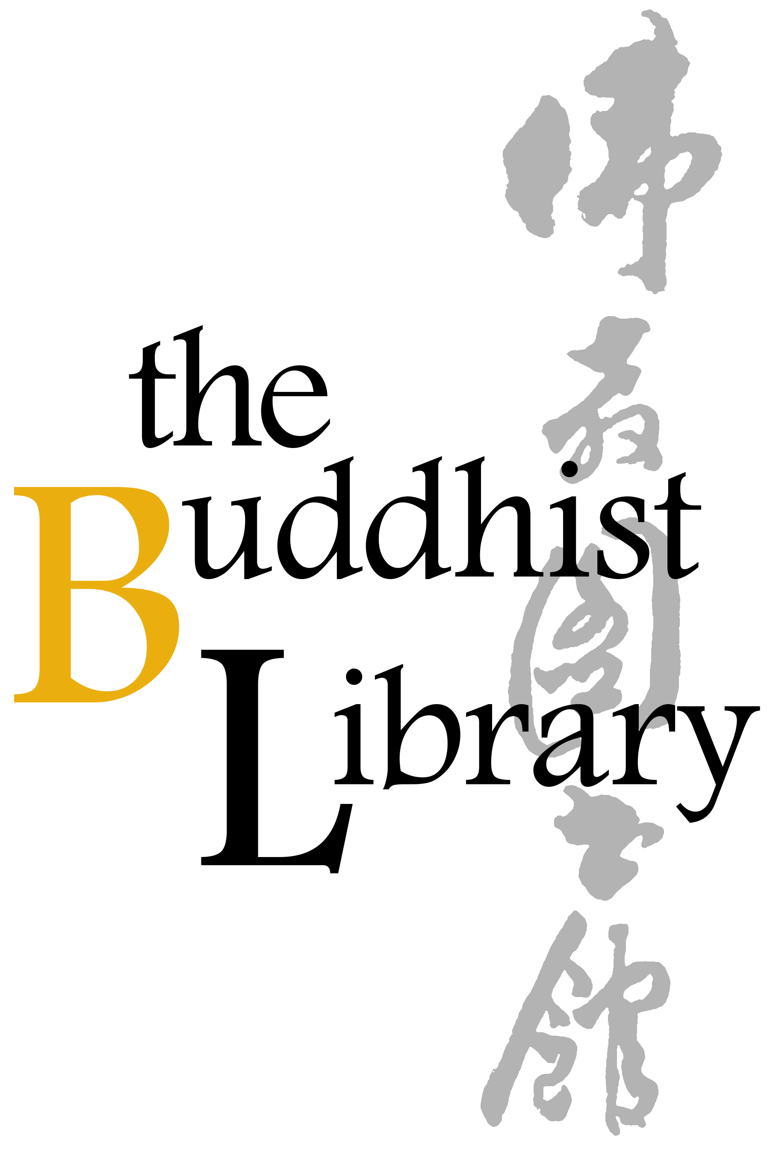
Parents’ Day Celebration 2026 Form
2026年 双亲节感恩午宴表格
Date 日期 | 3 May 2026 (Sunday) 2026年5月3日（星期日）
Time 时间 | 11.30am - 2pm 上午11时30分至下午2时
Fees  费用 | $788 per table (for 10 pax) | $88 per pax  每席（十位）$788 | 一位 $88

Please (1) fill up this reply slip (2) make payment (Paynow /Bank Transfer) (3) email reply slip to info@buddhlib.org.sg (4) Please paste screenshot of PayNow or bank transfer in your email. (5) Kindly note that if you are new to the Library, we will add you to our Mailing List; we currently send out an e-newsletter once every 1-2 months to update visitors on our Library programmes.
报名手续：(1)请填写以下"报名表格" (2)通过PayNow/银行转账付清费用 (3)请将表格电邮至 info@buddhlib.org.sg (4)如果通过PayNow/银行转账, 请截图并附在电邮中。(5) 如果您是图书馆的新用 户，我们会将您添加到我们的邮件列表中。我们目前每 1-2 个月发送一份电子通讯，为大众提供图书馆活动的最新信息。

Payment advice:
PayNow/PayLah to UEN S81SS0026HBRS (Buddhist Research Society Working Fund)

or scan QR code：
Internet transfer to DBS 0010193783 (Buddhist Research Society).
Cash and NETS are accepted at the Library.
*The Buddhist Library reserve the rights to change any part of the programme due to unforeseen circumstances.
Full Name 姓名
Email Address 电邮
Mobile Number 手机号码
Number of Table ($788 per table for 10 pax) 桌子数量【每席$788（十位）】  & / Or  Number of Pax ($88 per pax) 人数（一位 $88） | _________________Table(s) 席  & / Or  ____________________Pax 位
(Optional) Any donations are welcome. Your donations help keep the Library running. (随喜乐捐) 您的捐款将帮助图书馆继续举办活动和课程。
Total amount paid 总金额

