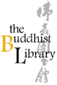 | Introduction to Pali Language 2026
 | Date & time: Wed 14 Jan – 8 April 2026* 7.30pm – 9.30pm Venue: Buddhist Library Fee: $50
a
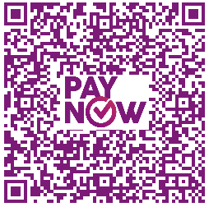
Please (1) fill up this reply slip (2) make payment (Paynow /Bank Transfer) (3) email reply slip to info@buddhlib.org.sg or mail to the Library (4) Please paste screenshot of PayNow or bank transfer in your email. (5) To avoid disappointment, please reply as soon as possible. (6) Kindly note that if you are new to the Library, we will add you to our Mailing List; we currently send out an e-newsletter once every 1-2 months to update visitors on our Library programmes.
a
报名手续：(1)请填写以下"报名表格" (2)通过PayNow/银行转账付清费用 (3)将表格电邮至 info@buddhlib.org.sg或邮寄至图书馆 (4)请截图PayNow/银行转账并附在电邮中。(5) 为了让图书做好安排，我们邀请您尽快回复（6） 如果您是图书馆的新用户，我们会将您添加到我们的邮件列表中。我们目前每 1-2 个月发送一份电子通讯，为大众提供图书馆活动的最新信息。
a
Payment advice. PayNow/PayLah to UEN S81SS0026HBRS (Buddhist Research Society Working Fund) or scan QR code：
Internet transfer to DBS 0010193783 (Buddhist Research Society). Cheque is made payable to “Buddhist Research Society”.
Cash and NETS are accepted at the Library. The Buddhist Library reserve the rights to change or cancel any part of the programme
due to unforeseen circumstances. No cancellations will be accepted.
Buddhist Research Society
Working Fund
Name of Participant: |  |  | a  (Optional) Any other donations are welcome. Your donations help keep the Library running.  (随喜乐捐) 您的支持会帮图书馆  继续主办活动和课程:)
Mobile phone:
Email:
 |  |  | Total amount:
 |  |  | Mode of Payment  (please indicate) | Paynow / Internet Transfer /  NETS/ Cash
 |  |  | Name of (PayNow) bank account holder, if different from name of registrant:
*If there are any changes in the class schedule, participants will be informed of these updates in class and through email.

