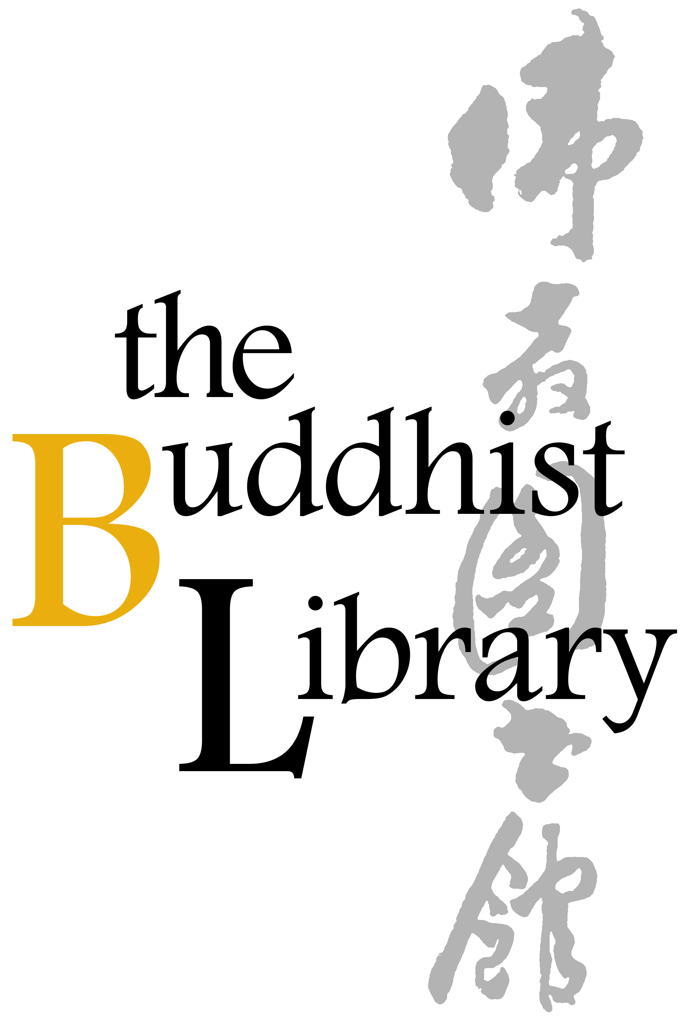
CHINESE NEW YEAR 2026
Lights Offerings Registration Form
2026年农历新年供灯登记表格
Offering Days  供灯日 | Day 1 – Day 15  正月初一至十五
Cost  供灯费用 | $20.00 per light offering per day  每盏灯 $20.00/一天
Details  详情 | Lights will be offered as part of our '108-Candle Tree' and illuminated for 24 hours. For safety reasons, LED candles will be used.  供灯将汇集于“108盏灯树” 并持续点亮24小时。出于安全考虑，我们将统一使用LED电子蜡烛。
Please (1) fill up this reply slip (2) make payment (Paynow /Bank Transfer) (3) email reply slip to info@buddhlib.org.sg (4) Please paste screenshot of PayNow or bank transfer in your email. (5) Kindly note that if you are new to the Library, we will add you to our Mailing List; we currently send out an e-newsletter once every 1-2 months to update visitors on our Library programmes.
报名手续：(1)请填写以下"报名表格" (2)通过PayNow/银行转账付清费用 (3)请将表格电邮至 info@buddhlib.org.sg (4)如果通过PayNow/银行转账, 请截图并附在电邮中。(5) 如果您是图书馆的新用 户，我们会将您添加到我们的邮件列表中。我们目前每 1-2 个月发送一份电子通讯，为大众提供图书馆活动的最新信息。
Payment advice:
PayNow/PayLah to UEN S81SS0026HBRS (Buddhist Research Society Working Fund)

or scan QR code：
Internet transfer to DBS 0010193783 (Buddhist Research Society).
Cash and NETS are accepted at the Library.
*The Buddhist Library reserve the rights to change any part of the programme due to unforeseen circumstances.
Full Name 姓名
Email Address 电邮
Mobile Number 手机号码
Offering Days 供灯日
Quantity of Lights to Offer供灯数量
(Optional) Any donations are welcome. Your donations help keep the Library running. (随喜乐捐) 您的捐款将帮助图书馆继续举办活动和课程。
Total amount paid [ $20 x Quantity + Donations (if any) ]
总金额 [ $20 x 数量 + 乐捐（若有）]

