Buddhist Library Funfair 2025

Date: Sun 16 Nov 2025, 9:00am - 4:00pm | Venue: Field next to Aljunied MRT Station

The Buddhist Library’s annual Funfair is back! On this meaningful, fun-filled day, we will have religious activities throughout the day (morning puja, blessings by the Sangha throughout the day as well as offering of lights and flowers), a very large variety of delicious vegetarian food, including food from local vegetarian restaurants and food stalls, and lots of shopping. We believe that you and your family will enjoy this fun-filled day with us.  The annual Funfair is one of the most important fund-raising events for the Buddhist Library—we are a charity and we rely on your contributions in order to continue our dharma activities. Thus, we hope that you can either sponsor part of the Funfair’s expenses or purchase Funfair tickets. | 

I would like to purchase ________ Funfair ticket books (Each book is $50).
- Following your purchase, we will email a receipt to you.
- Please have the person collecting the tickets bring this electronic receipt on 16 Nov, the day of the Funfair, and head to the Reception counter to pick up the tickets. (See next page for location map)
 | I would like to donate $_______________ for the expenses of the Funfair. Any amount is welcome!
Total amount paid: |  | $ | Name to issue receipt to:
Kindly note: if you are interested to be a stallholder at the Funfair, you can do so. Please email info@buddhlib.org.sg and leave your contact number so the Library can get in touch.


Instructions. Please (1) fill up the above fields (2) make payment (Paynow/Bank Transfer) (3) email reply slip to info@buddhlib.org.sg (4) Please paste screenshot of PayNow or bank transfer in your email. a
Payment advice. PayNow/PayLah to UEN S81SS0026HBRS (Buddhist Research Society Working Fund) or scan PayNow QR code：
a
Internet transfer to DBS 0010193783 (Buddhist Research Society). Cheque is made payable to “Buddhist Research Society”.
a
The Buddhist Library reserve the rights to change or cancel any part of the programme due to unforeseen circumstances.
Buddhist Research Society
Working Fund
Buddhist Research Society
Working Fund
. . . . .

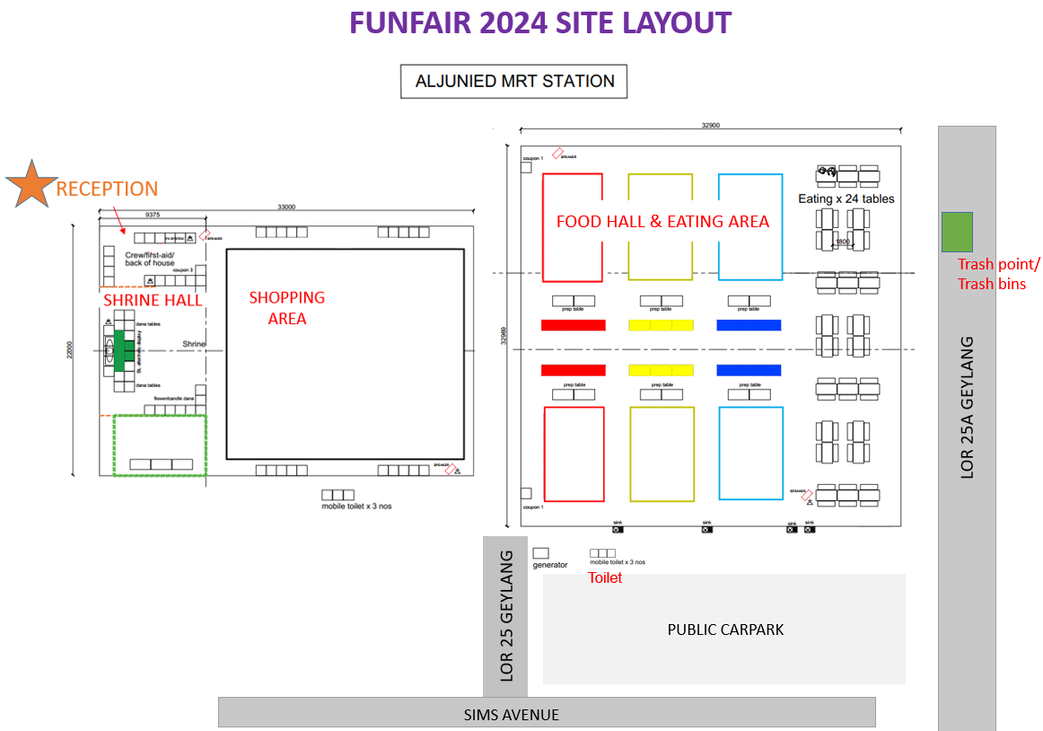
FUNFAIR 2025 SITE LAYOUT

