Buddhist Library Funfair 2025
佛教图书馆义卖会2025
Sunday 16th November 2025, Time: 9am – 4pm, Next to Aljunied MRT
Stall Application Form 义卖摊位表格

Please fill up and return this form to the Volunteer Manager in contact with you by 31 Oct 2025.
Or, if you are new to the funfair, please send the complete form to info@buddhlib.org.sg
CONTACT PERSON负责人姓名:
(Information for stall holders will be conveyed to this person)
HANDPHONE OF CONTACT PERSON手机号码:
EMAIL OF CONTACT PERSON 电邮:
NAME(S) OF STALL 摊位名称:
(THIS NAME WILL BE PRINTED ON YOUR STALL SIGNAGE 图书馆将此名称印在您的摊位标牌上)
NAME OF STALL SPONSOR 赞助摊位的名称
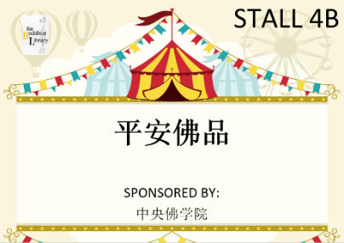  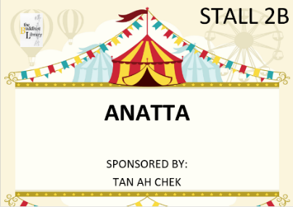  (THIS SPONSOR WILL BE ACKNOWLEDGED ON YOUR STALL SIGNAGE赞助摊位的名称也会印在标牌上. FOR EXAMPLE:) | 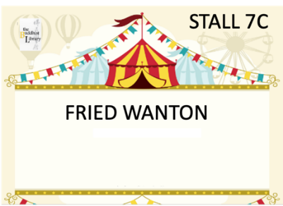  Sponsor field can also be left blank  不想放赞助摊位的名称，也可以

STALL CATEGORY摊位类别:  (PLEASE SELECT BY CIRCLING请选着一项) | FOOD / NON-FOOD  食物 / 礼品

NUMBER OF FRONT-FACING TABLES YOU ARE APPLYING FOR
要求的桌子数量 (前面的桌子):
(BY DEFAULT, EACH STALL IS ALLOCATED 2 FRONT-FACING TABLES AND 1 TABLE BEHIND YOU TO PUT YOUR BARANG-BARANG. ALL TABLES MEASURE 90CM X 90CM EACH.
每摊位一般有2张前面的桌子让大众买您的食物/礼品，还有1张后面的桌子放您的东西。每一张桌子尺寸为 90CM X 90CM。

FOR FOOD STALLS ONLY 食物摊位
PLEASE SPECIFY DETAILS OF YOUR FOOD食物种类 (VEGETARIAN FOOD ONLY 只限素食):
ELECTRICAL POINTS NEEDED 需要的电子插头数量:
(PLEASE BE ACCURATE AS 1 POWERPOINT COSTS $45 TO RENT
图书馆需要付$45租每一个插头､因此,请尽量确定数量)
PLEASE NOTE 请注意:
- Food must be prepared before the funfair, and then be brought to the funfair for sale. Open fire cooking and preparation of food on site is not allowed. Appropriate electrical appliances are to be used for warming of food.
- Please try to plan for at least $200 of sales. 注意: 请尽量实现至少 200 元的销售额。
EXAMPLES OF FOOD SOLD IN THE PAST INCLUDES THE FOLLOWING去年摊位卖的食物包括:

SNACKS, STREET FOOD & OTHERS  - French fries and nuggets， 薯条、素食鸡肉块  - FRIED WANTON (VEGAN) 炸素云吞  - KUEH PIE TEE 小金杯  - DUMPLING 粽子  - SOON KUEH 笋粿  - Radish cakes 菜头馃  - Yam Abacus 算盘子  - GLUTINOUS RICE糯米饭  - KEROPOK  - herbal ingredients and dried goods药材和干粮 | MAINS  - VEGETABLE CURRY咖喱杂菜  - LUO HAN ZAI罗汉斋  - LOR MEE卤面  - VEG BRAISED PORK RICE 素卤肉饭  - VEG CHICKEN RICE 素鸡饭  - VEG HAMBURGER 素汉堡包 | - LAKSA 拉沙  - 香味饭  - PINEAPPLE RICE 泰式凤梨饭  - CURRY MEE 加厘面  - MEE GORENG 印度炒面  - NASI LEMAK / OTAK 椰浆饭/乌打  - MEE SIAM 米暹  - FRIED RICE / NOODLES 炒饭/面  - ROJAK 罗惹 |  | DESSERT & DRINKS  - COLD DRINKS 冷饮料  - FRUITS 水果  - RED & GREEN BEAN SOUP 红绿豆汤  - PERANAKAN KUEH  惹娘糕点  - ICE CREAM 雪糕  - CAKES 糕点  - COOKIES 饼干  - COFFEE 咖啡

If you are operating a Food Stall with us for the first time, you will need to attend the Food Safety Level 1 Course (Venue, Date and Time will be advised soon). No payment is necessary, as the Library will pay for the costs. 如果您是第一次经营食物品摊，需要参加食品安全课程1级 （我们将尽快通知相关地点、日期和时间）。图书馆会支付费用，您无需付款。
FOR NON-FOOD STALL ONLY 礼品摊位

PLEASE SPECIFY DETAILS OF WHAT YOU ARE SELLING.
PLEASE TRY TO SELL NEW ITEMS ONLY, AND BE AS DETAILED AS POSSIBLE WHEN FILLING THIS FORM:
礼品种类。我们恳请摊主尽量卖新的礼品、
填此表格时请尽量分享详细信息。
PLEASE NOTE 请注意:
- Please try to plan for at least $200 of sales. 注意: 请尽量实现至少 200 元的销售额。
PAST EXAMPLES OF ITEMS SOLD INCLUDE去年摊位卖的礼品包括:
- BUDDHIST ITEMS 佛品
- BOOKS ON BUDDHISM佛书
- POTTERY陶器
- ART艺术品
- POTTED PLANTS植物
- CLOTHES服装
- ELECTRONICS, ETC. 电子产品、等等

. . . . .

