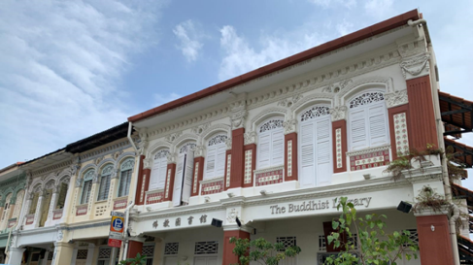
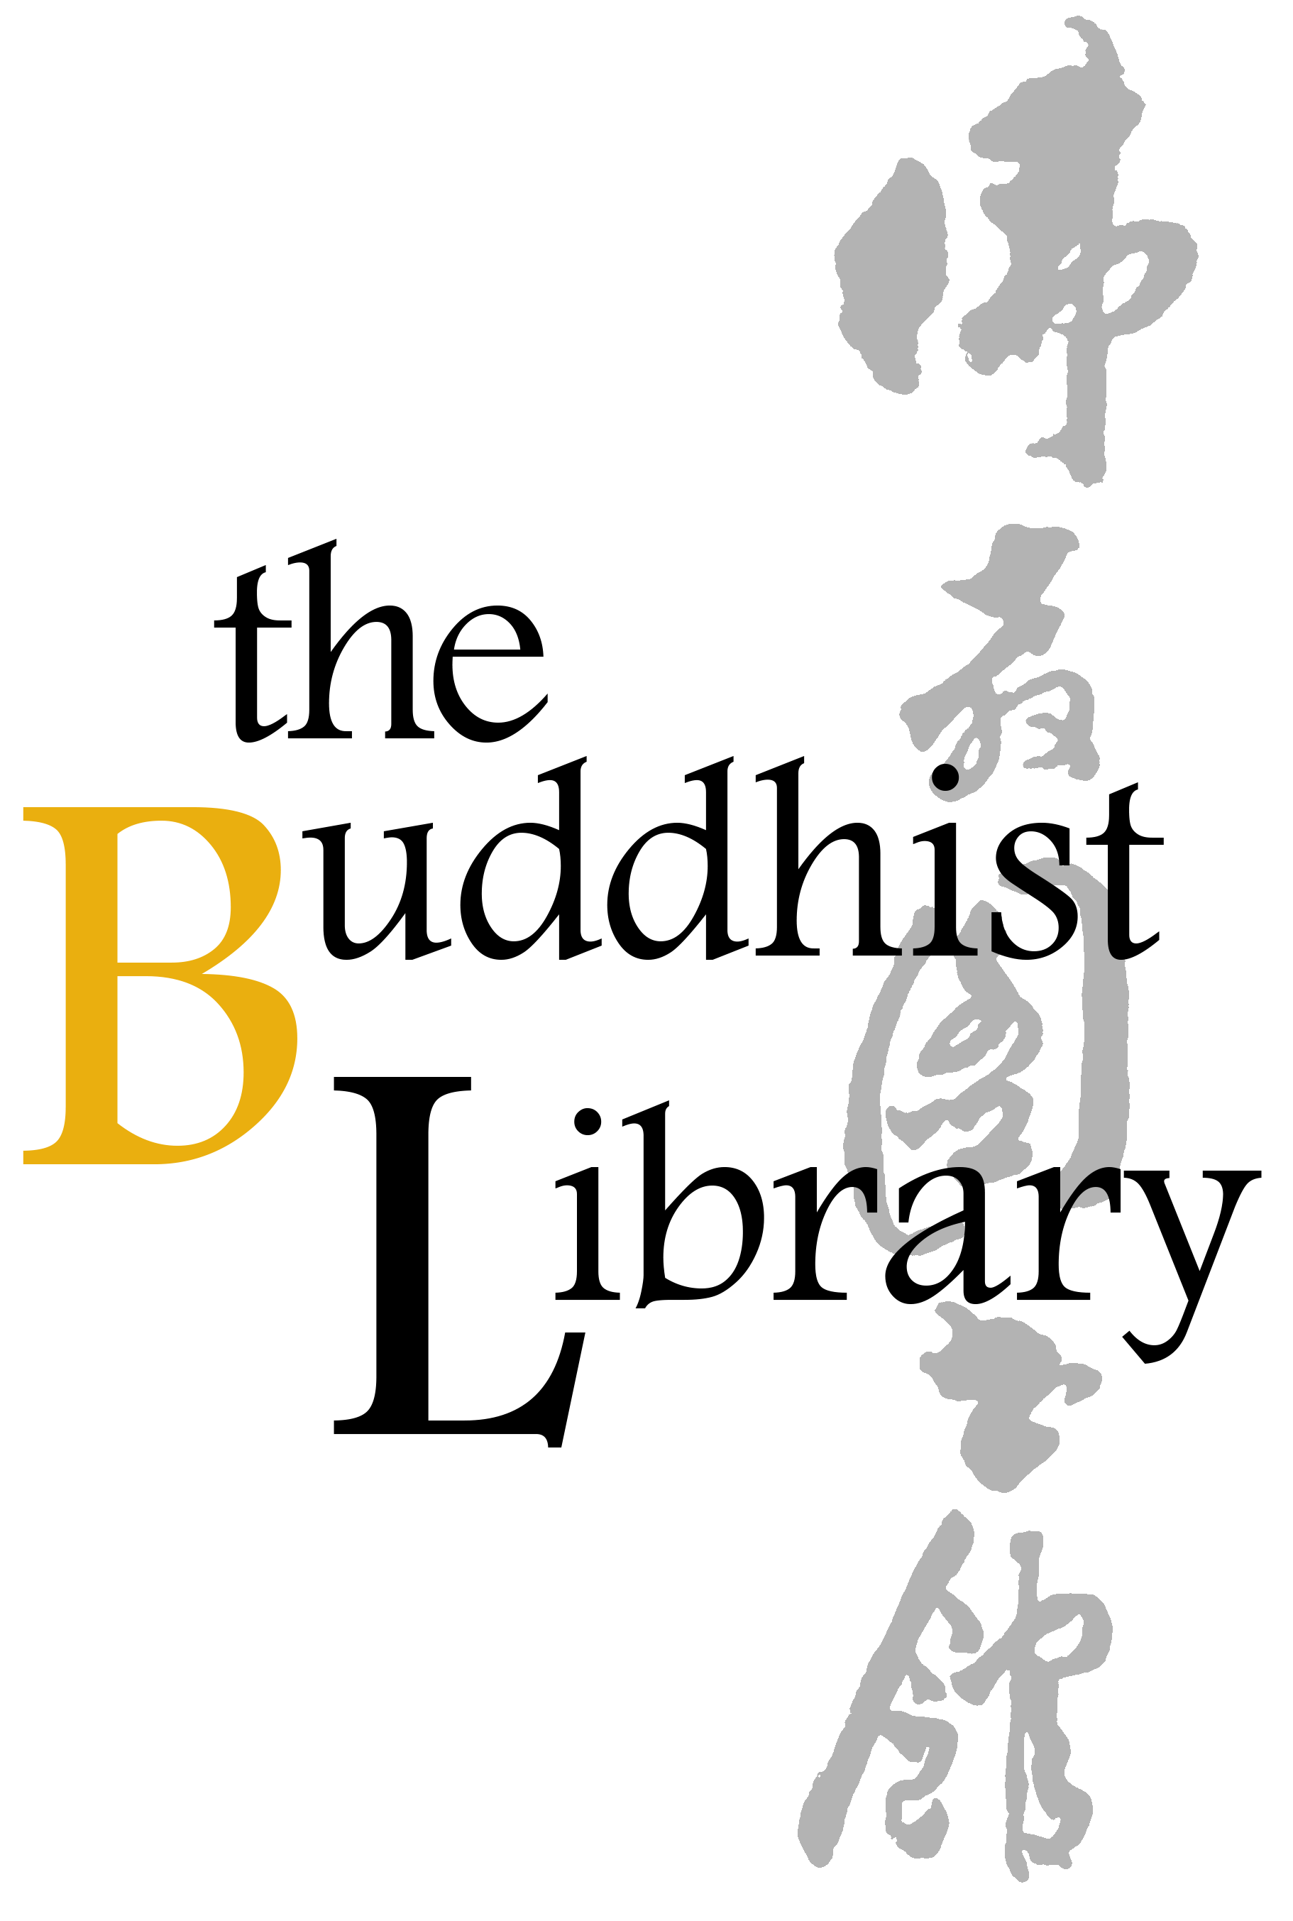
Buddhist Library Building Repairs 2025 Reply Slip
佛教图书馆维修工程2025 赞助表格

The Library will inscribe all names of Roof Tile Sponsors onto an Acknowledgment Plaque that will be installed onsite at the Library.
I would like to make the donations below. 我希望赞助以下的物品：
(You can mark the checkbox, like this: 您可以在此处打勾，例如: )
X
X
Sponsorship of Roof Tiles ($100/tile).  1 tile ($100)  10 tiles ($1,000)  100 tiles ($10,000)  Or, number of tiles  you wish to sponsor: ________ | 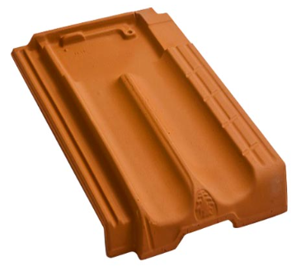  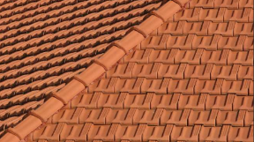  Marsaille inter-locking tiles as approved by URA.
Monetary donation: $

Purchase of Buddha Niche Statue for $2,388, with words of your choice engraved atop  (only 45 niches left in the Buddhist Library).  Please state which niche you desire (do visit the Library to look at the niches available)  Niche number: ____________ | 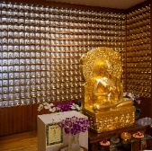  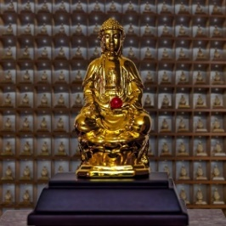  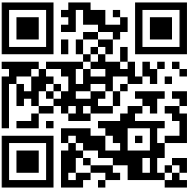  https://buddhlib.org.sg/bns
The engraved statue will be placed into its own niche in our “Sahasra Buddha Vyuha” (Matrix of a Thousand Buddhas), as per the centre image above. Full details and Reply Slip available through QR/webpage/hard-copy brochure at the Library.
Total amount donated | $
Please turn to next page to fill up Sponsor’s Name as well as for
Payment Instructions.
Sponsor Details
Name of Roof Tile Sponsor(s), in CAPITAL LETTERS 赞助者姓名

(This name will be inscribed on the plaque)
PLEASE NOTE: 1 NAME PER TILE
Other typical and acceptable inscriptions:
- <<YOUR NAME>> & FAMILY
- <<NAME OF ORGANISATION/COMMUNITY/COMPANY>>
- MR AND MRS <<NAME>> AND FAMILY

a
Important! Please also double-check the name printed on your receipt; this name will be inscribed on the acknowledgment plaque and cannot be changed
a
请注意！请仔细检查收据上打印的姓名；
此姓名将刻在捐赠者名录上，且不可更改
a
Name of registrant, if different from above 报名者姓名:
(Receipt will be issued to this person 将向此人发出收据)
Contact details联系方式 Please double-check that you have keyed in correctly请仔细检查您是否输入正确。
Mobile phone手机:
Email 电邮:
Mode of Payment  (please indicate): | Paynow / Internet Transfer /  NETS/ Cash / Cheque
Name of (PayNow) bank account holder, if different from name of registrant:
Address (only for payment by cheque)
地址（仅适用支票付款）:

Payment Instructions
Please (1) fill up this reply slip (2) make payment (Paynow /Bank Transfer/Cheque) (3) email reply slip to info@buddhlib.org.sg or mail to the Library (4) Please paste screenshot of PayNow or bank transfer in your email. (5) Kindly note that if you are new to the Library, we will add you to our Mailing List; we currently send out an e-newsletter once every 1-2 months to update visitors on our Library programmes.
a
报名手续：(1)请填写以下"报名表格" (2)通过PayNow/PayLah/支票/付清费用 (3)将表格电邮至 info@buddhlib.org.sg或邮寄至图书馆。(4)如果通过PayNow/PayLah, 请截图并附在电邮中。（5） 如果您是图书馆的新用户，我们会将您添加到我们的邮件列表中。我们目前每 1-2 个月发送一份电子通讯，为大众提供图书馆活动的最新信息。

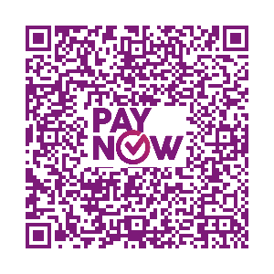
Payment advice. PayNow/PayLah to UEN S81SS0026HBRS (Buddhist Research Society Working Fund) or scan QR code. Internet transfer is to DBS 0010193783 (Buddhist Research Society). Cash and NETS are accepted at the Library.
Buddhist Research Society
Working Fund

