**Buddha Niche Statue*严佛壁****Donate a Statue, Support the Work of the Buddhist Library 赞助佛像与木窟，  
帮我们继续为您服务*

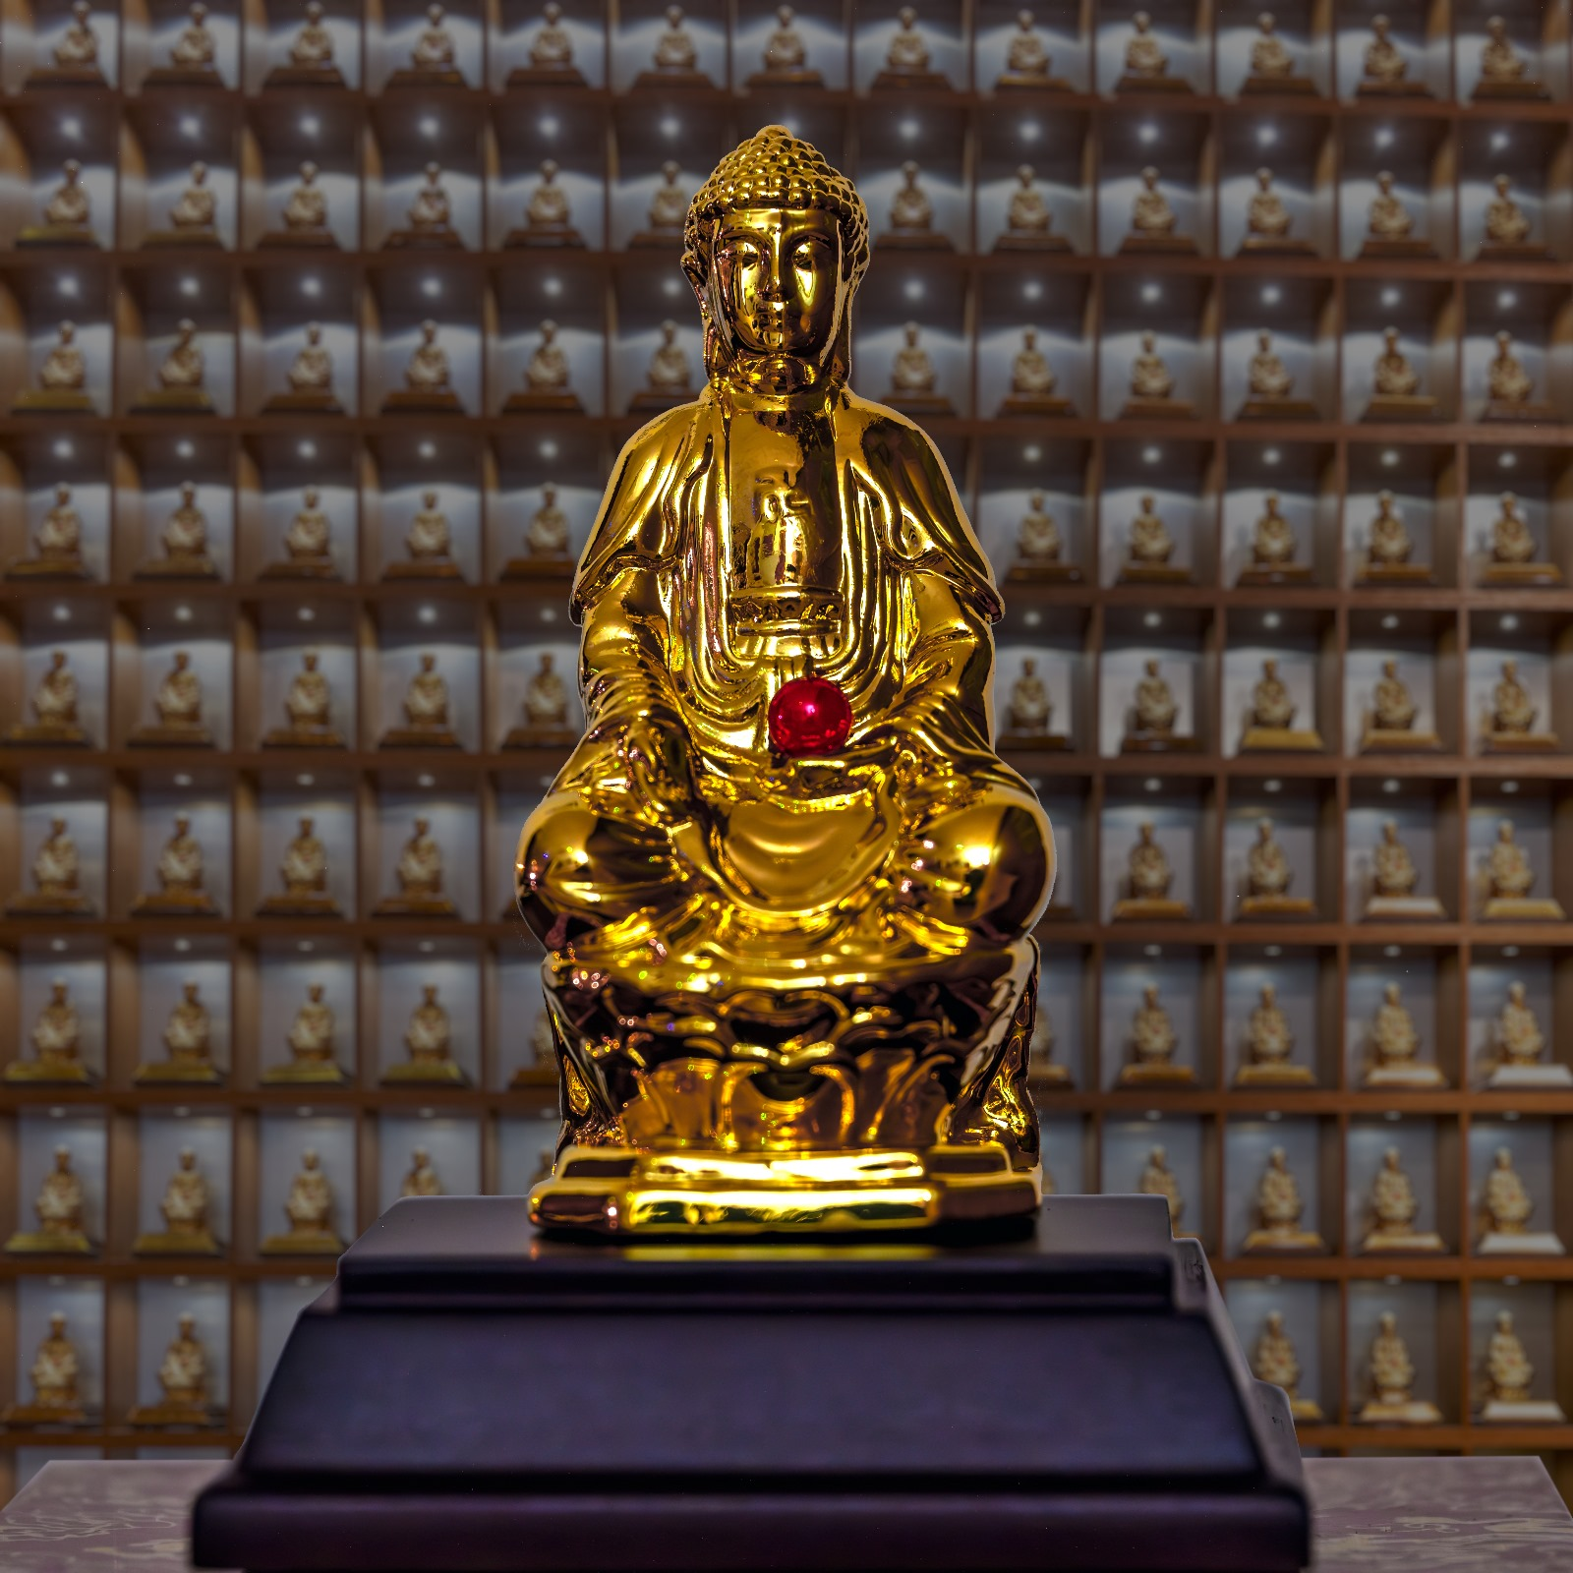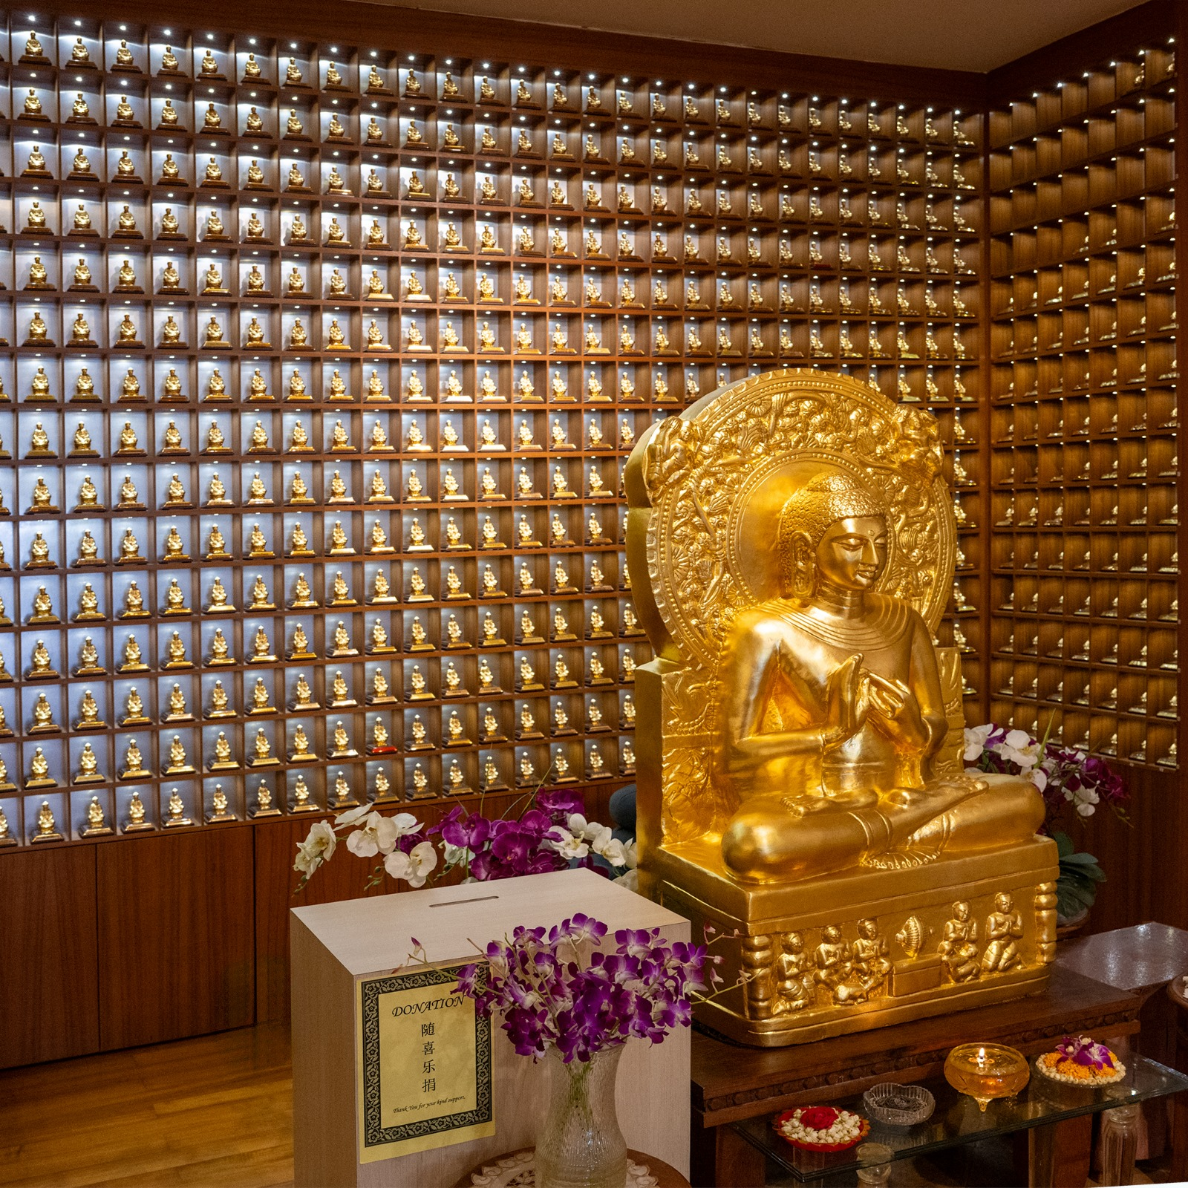

**Background of the Buddha Niche Statue & Matrix of a Thousand Buddhas 严佛壁缘起**  
  
In 2003, Buddhist Library launched the “Sahasra Buddha Vyuha” (Matrix of a Thousand Buddhas) Project to raise funds for the Library. The project involved transforming the wall behind the granite Buddha statue in the Art Gallery into a wall of Buddhas. 620 niches or so were created and each contains a gold-plated Buddha specially imported from China and individually lighted. The response was encouraging as many supporters came forward to sponsor the Buddha statues. As of today, there are only 45 statues left which remain undonated. You can see this when you visit the Art Gallery, where there are 45 empty niches.

Proceeds from the “Sahasra Buddha Vyuha” Extension Project have helped finance the expansion of the auditorium—it used to be smaller—and renovating the monks’ quarters, and ***we will now channel funds raised to our Building Repairs 2025 work.***

The Buddhist Library has come a long way and this would not have been possible without the support of its members and devotees. We hope you will continue to lend us your support and generosity so that we can continue to be of service to you. May the collective merits of the   
  
project bring you and your family everlasting peace and joy.

佛教图书馆于二零零三年为了筹款，将艺术画廊花岗石佛像后那道墙改设成 “严佛壁”，造了大概六四百二十个木窟。木窟里的镀金佛像是特别从中国入口，而且每一樽都有一盏灯亮着。这些年来，“严佛壁”一直深获信徒们的支持。截至今天，仅剩下 45 木窟与佛像未捐赠。

“严佛壁” 扩建项目的收益已经帮了我们扩大二楼讲堂（以前规模较小）和装修僧侣的僚房，***现在我们将把筹集到的资金用于我们的“Building Repairs 2025”项目。***  
这些年一路走来，要不是会员和信徒的支持，佛教图书馆难有今天的规模与设备。我们希望您将继续支持和慷慨解囊，使我们能继续为您服务。祈愿这项目的集体功德，带给您和您的家人永久的和平和喜悦。  
 **Statues Details and Inscriptions of Your Preference   
关于佛像和铭文的详情**  
Each of the Buddha statues occupying the 645 niches is exquisitely made and directly imported from China. Each 8cm tall gold-plated statue sits on a 2.5cm tall wooden stand.

Words of your choice will be engraved on a metallic plate to be placed on the front of the wooden stand.

Each niche will also be individually lighted by a small light. Together with the big granite Buddha statue sitting in the front, it will certainly be an inspiring sight, most suited to meditation and prayer. The cost of each statue and niche is $2,388.  
  
安置于【严佛壁】的六百四十五个佛像是直接从中国入口。各镀金佛像高八公分，坐立在一个高二点五公分的木制平台。  
  
您选择的文字将被刻在平台的前面。  
  
每个佛像都会由各自的灯光照明。加上现有从印度进口的花岗石大佛像，整个【严佛壁】将会体现出一个庄严的感觉，尤其适合于静坐或诵经等修行。



Types of Inscriptions Devotees Typically Make信徒通常会刻的铭文类型

|  |  |  |  |  |
| --- | --- | --- | --- | --- |
| **Type of inscription** | **Examples** |  | 类别 | 例子 |
| a  (1) *A name/names* | a   * 《YOUR NAME》 * 《YOUR FAMILY MEMBERS’ NAME[S]》 * 《THE NAME OF YOUR ORGANIZATION, COMMUNITY OR COMPANY》 * Et. Cetera.   a |  | a  (1)您的名字/几个名字 | a   * 《您的名字》 * 《家人的名字》 * 《您所在的组织/机构/公司名字》 * 等等 |
| a (2) *A message  of your wish* | a   * “MAY ALL BEINGS BE WELL AND HAPPY” * “MAY WE ALL GAIN ENLIGHTENMENT” * Et. Cetera.   *a* |  | a  (2)一句您的愿望 | a   * “不为自已求安乐,  当願众生得離苦” * “世界和平” * “一切众生” * 等等 |
| a  (3) *The name of  a deceased person(s)* | a   * 《THAT PERSON’S NAME》 * “IN MEMORY OF…” / * “已故...” * “回向已故…” * Et. Cetera. |  | a  (3)已故之人的名字 | a   * 《名字》 * “纪念…” * “已故…” * “回向已故…”, * 等等   a |
| A (4) *A blank plate/ anonymous a* |  |  | a  (4)平台空白/匿名 |  |
| **Please note:**  Most of the inscriptions in English have been 3 to 10 words long.  However, if desired, we will try to accommodate longer messages. a Inscriptions in English have been and will continue to be done in CAPITAL LETTERS. a A combination of English and Chinese words is also possible, of up to 12 words or so. Likewise, we will try to accommodate if the message exceeds that length. | |  | **请注意:** 大多数中文铭文的长度为 3 到 15 个字。 如果需要，我们会尝试容纳更长的消息。  也可以是英文和中文的组合，最多 12 个字左右。 同样，如果消息超过该长度，我们也会尽量满足。 | |

|  |  |
| --- | --- |
|  | ***Buddha Niche Statue 严佛壁* Sponsorship Fee 赞助费:** **$2,388***Donate a Statue, Support the Work of the Buddhist Library 赞助佛像与木窟，帮我们继续为您服务* |

a  
Please **(1)** fill up this reply slip **(2)** make payment (Paynow /Bank Transfer/Cheque) **(3)** email reply slip to [info@buddhlib.org.sg](mailto:info@buddhlib.org.sg) or mail to the Library **(4)** Please paste screenshot of PayNow or bank transfer in your email. **(5)** Kindly note that if you are new to the Library, we will add you to our Mailing List; we currently send out an e-newsletter once every 1-2 months to update visitors on our Library programmes.   
a  
报名手续：**(1)**请填写以下"报名表格" **(2)**通过PayNow/PayLah/支票/付清费用 **(3)**将表格电邮至 [info@buddhlib.org.sg](mailto:info@buddhlib.org.sg)或邮寄至图书馆。**(4)**如果通过PayNow/PayLah, 请截图并附在电邮中。**（5）** 如果您是图书馆的新用户，我们会将您添加到我们的邮件列表中。我们目前每 1-2 个月发送一份电子通讯，为大众提供图书馆活动的最新信息。

***a  
Payment advice.*** PayNow/PayLah to **UEN S81SS0026HBRS** (Buddhist Research Society Working Fund) or **scan QR code：**Internet transfer to **DBS 0010193783** (Buddhist Research Society). Cash and NETS are accepted at the Library. The Buddhist Library   
reserves the rights to change or cancel any part of the programme due to unforeseen circumstances. No cancellations will be accepted.

|  |  |  |  |  |
| --- | --- | --- | --- | --- |
| **We wish the following words to be engraved** 我们希望以下的字刻在佛像平台的前面**: a *(Note: for English words, please type/write in  CAPITAL LETTERS)*** | | | **a  Name of D*o*nor 报名者姓名:**  ***(Receipt will be issued to this person将向此人发出收据)*** | *Buddhist Research Society  Working Fund* |
|  |  | |
|  |  | | **Mobile phone手机:** |  |
| *Note for English inscriptions: Most of the inscriptions in English have been 3 to 10 words long. However, if desired, we will try to accommodate longer messages. We will do up a layout of the words on the metallic plate after you provide them to us. 大多数中文铭文的长度为3到15个字。如果需要，我们会尝试容纳更长的消息。当您将平台前的文字提供给我们后，我们就会对其进行布局。* | | | **Email 电邮:** |  |
| **Mode of Payment  *(please indicate)*** | Paynow / Internet Transfer /  NETS/ Cash / Cheque |
| **Desired niche location** 木窟号码:(Please visit the Library to view the niche locations that are available 请访问图书馆查看未捐赠的木窟) | |  | **Name of (PayNow) bank account holder, if different from name of registrant:** |  |
|  | **Address (only for payment by cheque) 地址（仅适用支票付款）:** |  |
|  |