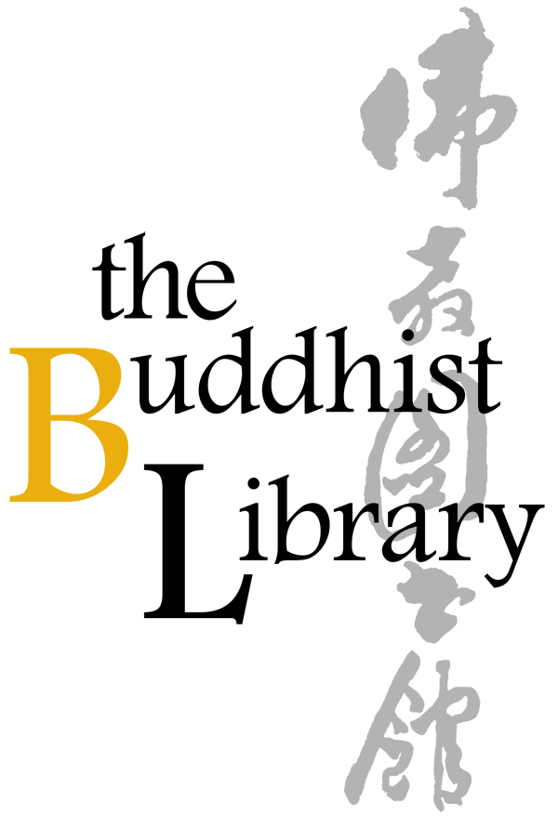 | Mindfulness for Young Children 2023
 | Sundays at 2-3.30PM
Venue: The Buddhist Library, No 2 Lorong 24A Geylang Road S(398526)
Fees: $30 per semester

Semester 1 dates  Pre-school and lower primary  – 1st and 3rd Sundays of the month  Feb 5, 19  Mar 5, 26  Apr 9, 23 | Upper primary– 2nd and 4th Sundays of the month  Feb 12, 26  Mar 19, Apr 2  Apr 16, 30
Please fill up this reply slip. Payment instructions are below.

Student particulars

Full name in English:
Name in Chinese characters or Pin Yin (if applicable)
Gender:
Date of Birth:
Nationality:
School in 2023:
School level in 2023 e.g. (Nursery 2/Kindergarten 2/Pri 3, etc.)
Please affix photo of child, to aide Venerable/the teachers in quickly recognising your child:
If applicable, please list talents/Skills (e,g, playing musical instrument, dance, singing, etc.)
Dharma knowledge: basic/intermediate/advanced/others (please specify)
Name of registrant:
Relationship to student (e.g. father/grandmother, etc.):
Contact number of registrant:
In case of emergency, is the person to contact the registrant? | Yes/No
If “No”, please indicate name and contact number of
emergency contact and how student is related:

<Payment instructions are on the next page>

Mode of Payment (please indicate): Cash / Nets / Cheque/ Internet Transfer / Paynow

Payment advice. You can PayNow/PayLah to UEN S81SS0026HBRS (Buddhist Research Society Working Fund). Internet transfer to DBS 0010193783 (Buddhist Research Society). Cheque is made payable to “Buddhist Research Society”. The Buddhist Library reserve the rights to change or cancel any part of the programme due to unforeseen circumstances. No cancellations will be accepted.

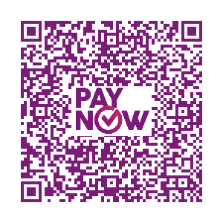
Please paste screenshot of bank transfer in your email or in this word document.

