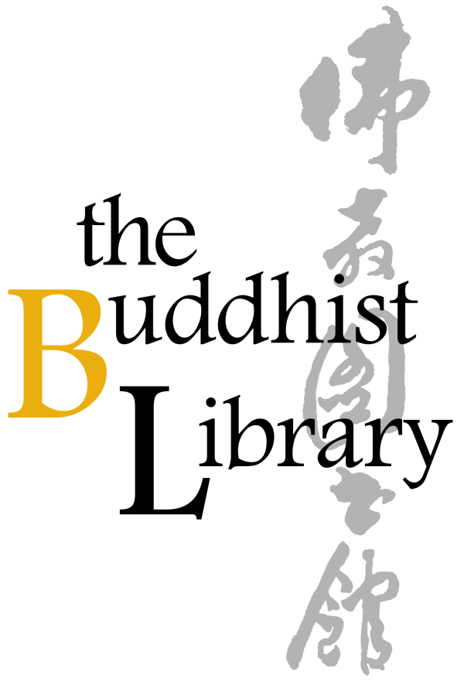 |  | Great Compassion Mantra
 |  | Date: 5 Oct to 14 Dec (Every Fri) 2018 *No class on 12 Oct
 |  | Time: 7.30pm – 9.00pm
 |  | Venue: The Buddhist Library, No 2 Lorong 24A Geylang Road S(398526)
 |  | Office: 6746 8435
 |  |  |  |  | Email: info@buddhlib.org.sg
 | BL Members $30 Non Members $50
 | Name of Participant: |  |  |  | Email: | ___________
 | Address: |  |  |  | HP :
 | Mode of Payment: | Cash / Nets / Cheque |  |  | Amount:
 | Signature: |  |  |  | Date :
 | *Cheque is made payable to “Buddhist Research Society”. The Buddhist Library reserve the rights to change or cancel any part of the programme due to unforeseen circumstances. No cancellations will be accepted.
 | The Buddhist Library  No.2, Lorong 24A Geylang Road, Singapore 398526  Telephone: (+65) 6746 8435 Fax: (+65) 6741 7689  Email: info@buddhlib.org.sg  Website: http://www.buddhlib.org.sg |  |  |  | Library Opening Hours  Tues to Sat: 12:00 noon - 9:00pm  Sun: 10:00am - 9:00pm  Closed on Mondays  Open on Public Holidays

