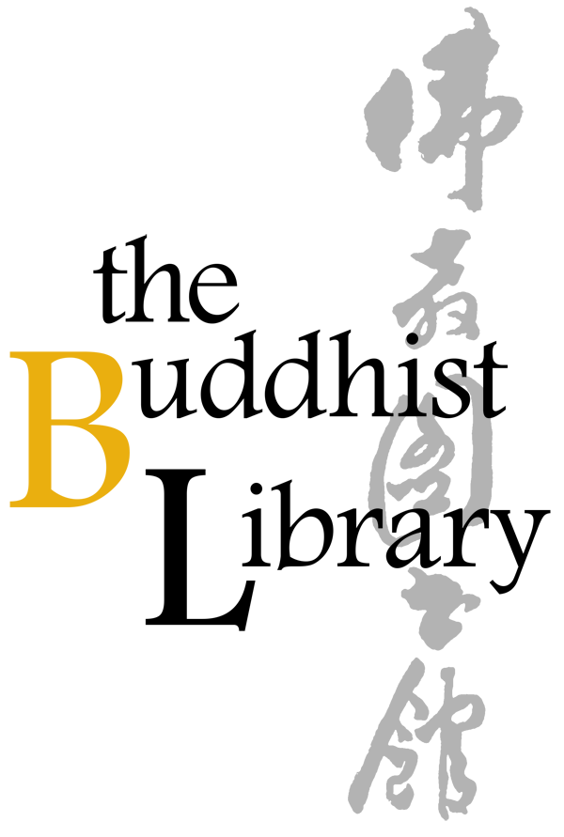 |  | Medicine Buddha Puja 药师佛法会 2018
 |  | Date: 4 Nov 2018 (Sun)
 |  | Time: 10.00am – 5.00pm
 |  | Venue: The Buddhist Library, No 2 Lorong 24A Geylang Road S(398526)
 |  | Office: 6746 8435
 |  |  |  |  | Email: info@buddhlib.org.sg
Please fill up this reply slip and make payment (Cash, Netts, or Cheque) at The Buddhist Library
*$30 for 2 names, $50 for 4 names两个名字$30，四个名字$50
 | Name of Participant 参与者(1):
 | Address 地址: |  |  |  | HP 手机号:
 | Mode of Payment 付款方式: | Cash / Nets / Cheque |  |  | Amount:
 | Name of Participant 参与者(2): |  |  |  | Email 电邮:
 | Name of Participant 参与者(3):
 | Name of Participant 参与者(4):
 | Signature 签名: |  |  |  | Date 日期:
 | *Cheque is made payable to “Buddhist Research Society”. The Buddhist Library reserve the rights to change or cancel any part of the programme due to unforeseen circumstances. No cancellations will be accepted.
 | The Buddhist Library  No.2, Lorong 24A Geylang Road, Singapore 398526  Telephone: (+65) 6746 8435 Fax: (+65) 6741 7689  Email: info@buddhlib.org.sg  Website: http://www.buddhlib.org.sg |  |  |  | Library Opening Hours  Tues to Sat: 12:00 noon - 9:00pm  Sun: 10:00am - 9:00pm  Closed on Mondays  Open on Public Holidays

