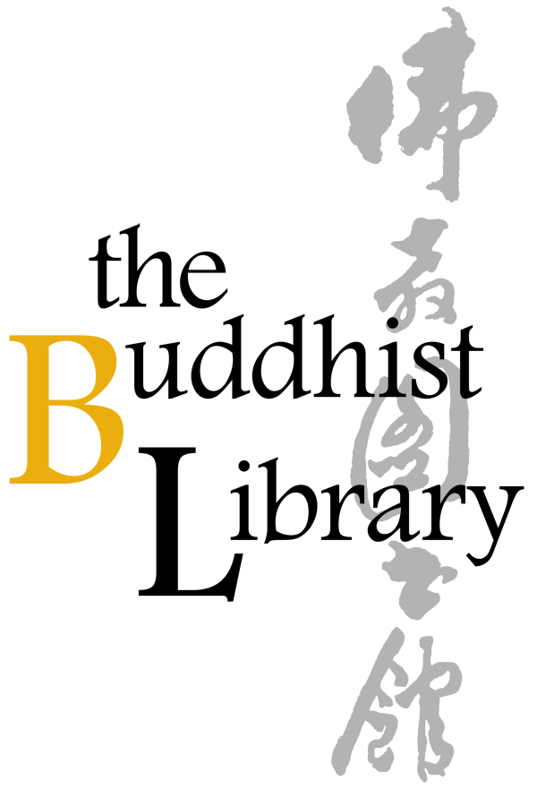 |  | Living a Loving and Awakened Life
 |  | Date: 22 Nov 2018 to 07 Mar 2019 (Every Thur) *Break on 20 & 27 Dec, 3 Jan & 7 Feb
 |  | Time: 7.30pm – 9.00pm
 |  | Venue: The Buddhist Library, No 2 Lorong 24A Geylang Road S(398526)
 |  | Office: 6746 8435
 |  |  |  |  | Email: info@buddhlib.org.sg
Please fill up this reply slip and make payment (Cash, Netts, or Cheque) at The Buddhist Library
*$30 per pax

 | Name of Participant:
 | Address: |  |  |  | HP :
 | Mode of Payment: | Cash / Nets / Cheque |  |  | Amount:
 | Signature: |  |  |  | Date :
 | *Cheque is made payable to “Buddhist Research Society”. The Buddhist Library reserve the rights to change or cancel any part of the programme due to unforeseen circumstances. No cancellations will be accepted.
 | The Buddhist Library  No.2, Lorong 24A Geylang Road, Singapore 398526  Telephone: (+65) 6746 8435 Fax: (+65) 6741 7689  Email: info@buddhlib.org.sg  Website: http://www.buddhlib.org.sg |  |  |  | Library Opening Hours  Tues to Sat: 12:00 noon - 9:00pm  Sun: 10:00am - 9:00pm  Closed on Mondays  Open on Public Holidays

